

This has been a good year for us, although it has been sprinkled with sadness as the aging process takes its toll on our family. My mother has struggled with a number of health issues over the years and they seem to be getting the best of her now. She has been in and out of hospitals, rehab centers and nursing homes for most of the year. She has gone from an independent willful woman to someone who is able to communicate very little. She seems peaceful now though which is a blessing for our family. She is in the Bell Minor Nursing Home and my father is at Smoky Springs Retirement Home in Gainesville.

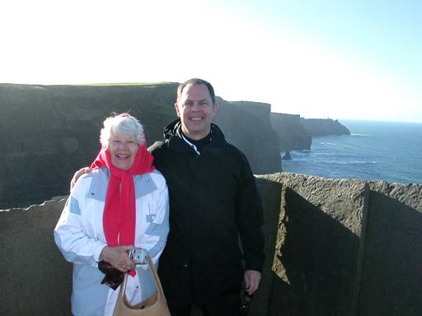
The year started with my father in the hospital having had successful surgery just before Christmas to relieve the pressure of a bone spur impinging on his spine. He came through the surgery like a champ, but had to be in rehab for three weeks. My mother insisted on staying at home alone, but we finally convinced her to move into an Independent Living Facility called Smoky Springs where her meals would be provided along with some minimal assistance. She really seemed to enjoy being there and participated in many of the activities. Having both of my parents squared away gave us a chance to enjoy some time with Tony’s mom (who is doing great, by the way). We took her and a friend to Ireland in early February and had a great time showing the little old ladies around!

Shortly after we got back, my mother’s health started to deteriorate. She spent the last half of February alternating between the hospital and the rehab center. I spent a great deal of time driving back and forth to Gainesville. Tony took a quick trip to back to Ireland to shop for a Garden Gnome that we had seen on a previous trip and wanted to give to a friend as a house warming gift.
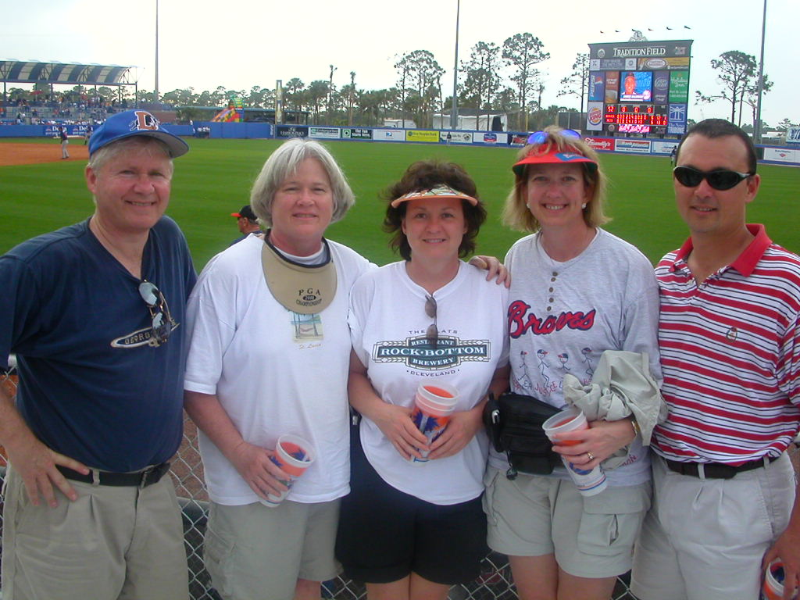
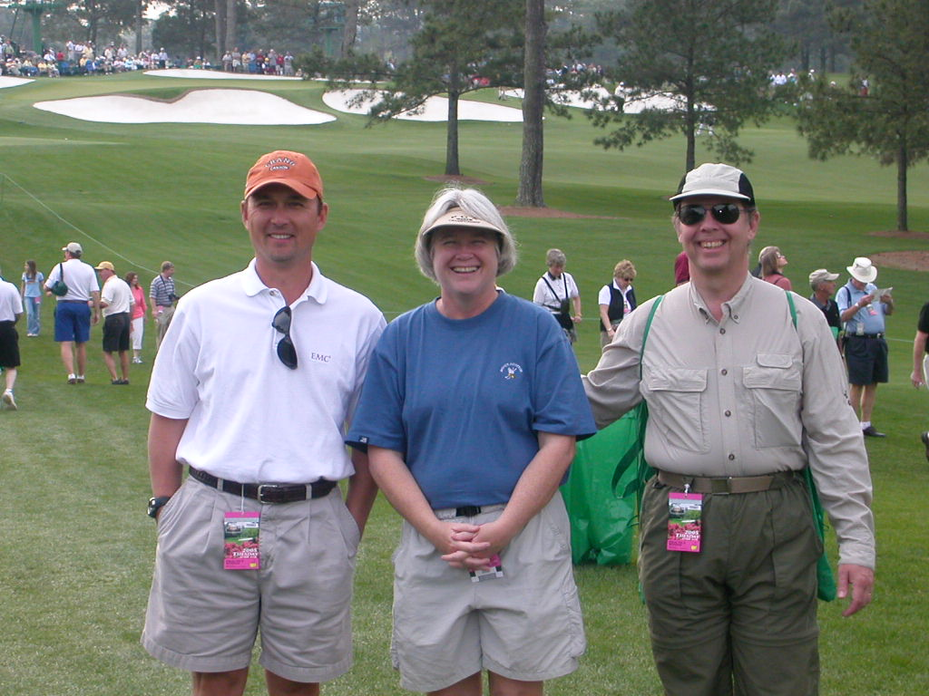
Mother was released from rehab and got settled back into Smoky Springs in time for us to go on a wonderful ski trip to Salt Lake City with some friends in March, but she was readmitted to the hospital soon after we returned. She spent more time in rehab. I was able to work in a day trip with friends to a Braves Spring Training Game in Melbourne, Florida.

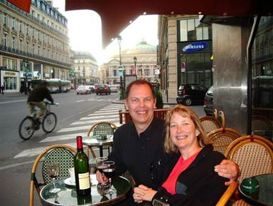
In April, we got to go to the Masters Practice Round with our friends Bobby and JeRie to see how the REAL golfers play.
We took a two day trip to Paris with Tony’s brother just for lunch! It was the most expensive meal we’ve ever had!
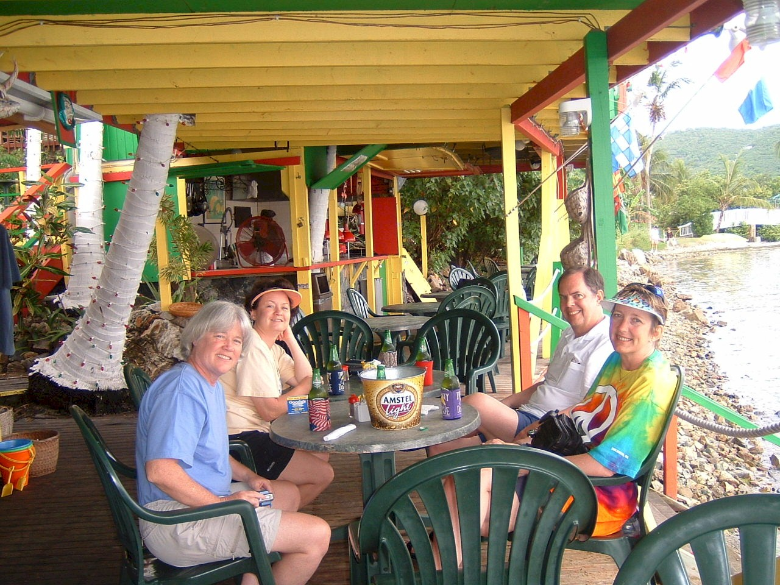
I took a business trip to Denver, CO and then we had a relaxing weekend in St. Thomas V.I. with friends. We judged a BBQ Contest in Columbus, Georgia in between.
May started with Mother back at the Emergency Room. She was released shortly afterward, but we had to find caregivers to help her.

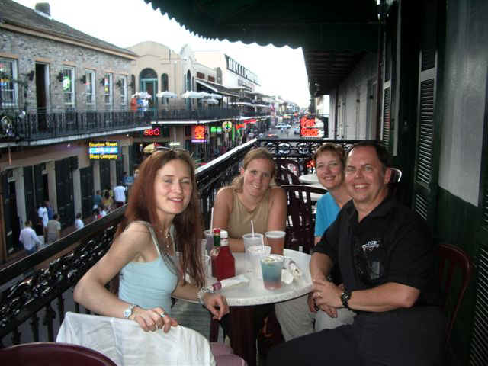
May brought a new bright spot in our lives. We started hosting a German intern. We found Carina through a friend at work. She was looking for a place to live while she did an internship in Event Management at Messe Frankfurt. She’s 27 years old and has just been a delight!

In June, Mother did another stint in the hospital followed by an extended stay in rehab, finally getting out in July. She was doing pretty well, so we took a quick trip to New Orleans to show Carina and her friend Cindy the French Quarter. Little did we know that we were seeing it for the last time before it would be under water.
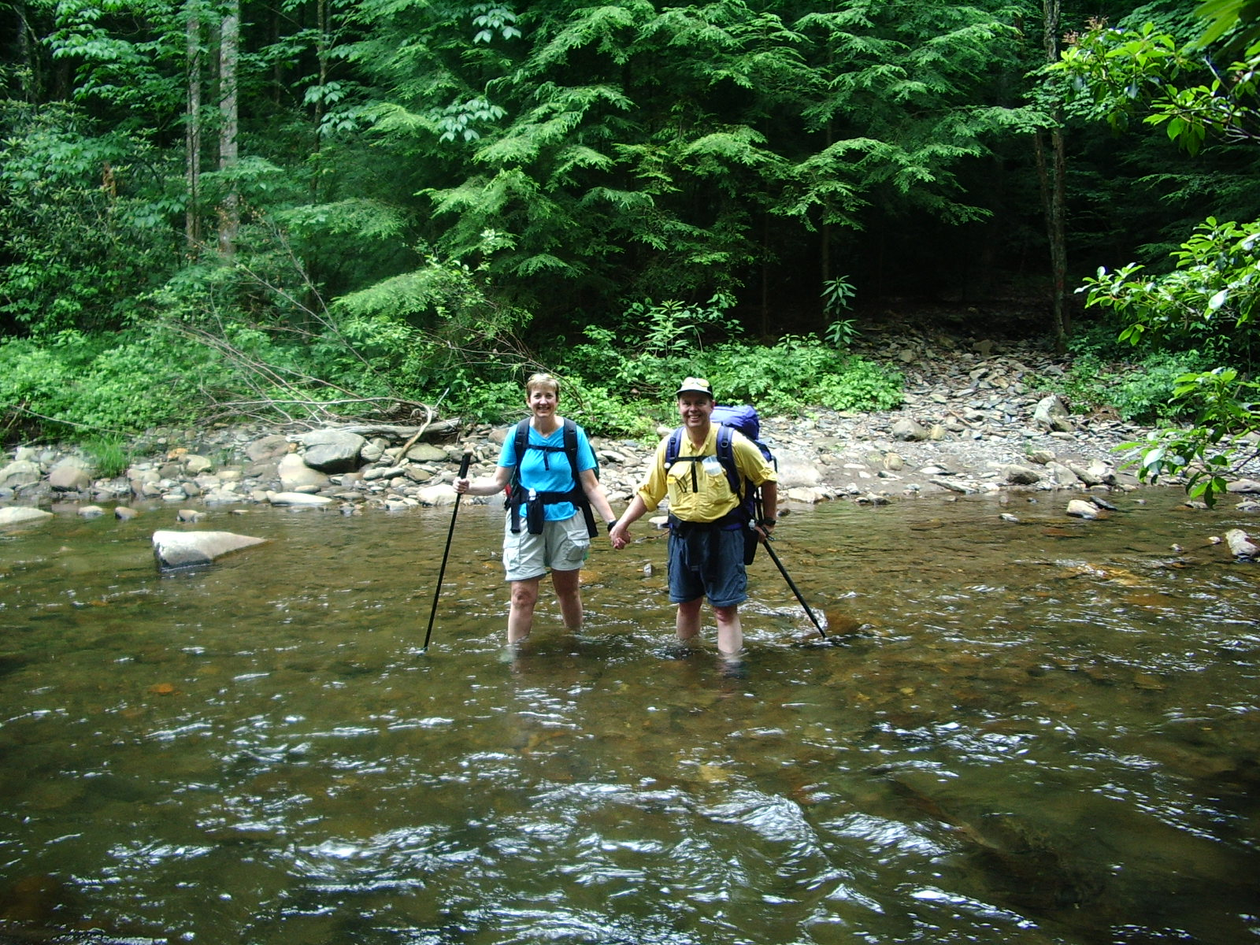
We went on a backpacking trip to Dally Gap in the North Georgia Mountains with some friends. The trail had seventeen river crossings on the way in and was straight uphill on the way out!

Later in the month, we went down to St. George Island, Florida to see our friends’ fabulous new beach house. We got so inspired by their beautiful new kitchen that we put new Corian countertops in our kitchen. We were without a kitchen for 3 weeks during the installation. We should have lost weight, but we didn’t. I had a “girls only” weekend at a friend’s cabin in Sky Valley. We grilled out and played golf. At the end of the month, we went to the Worldspan Golf Tournament in Amelia Island, South Carolina.

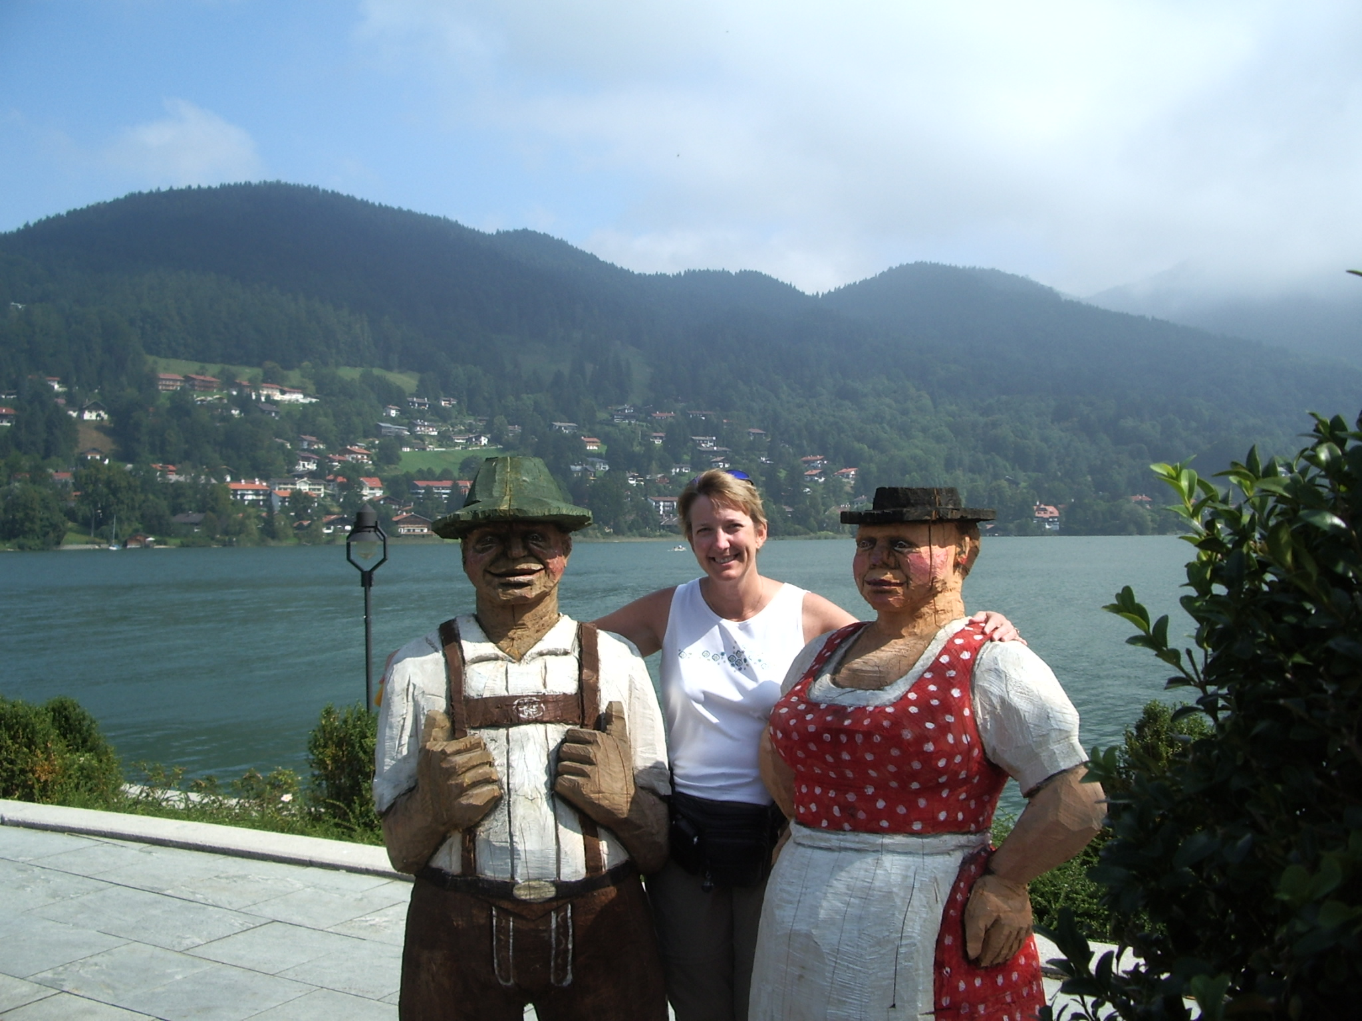
Mother took a turn for the worse again in August and we had to increase the amount of care she was receiving. Tony and I were able to fit in a day trip to Nashville to judge BBQ at the Fiddlin’, Brewin’, and Bar-B-Q’n contest at Opryland and I attended a weekend Bachelorette Party at Lake Burton.

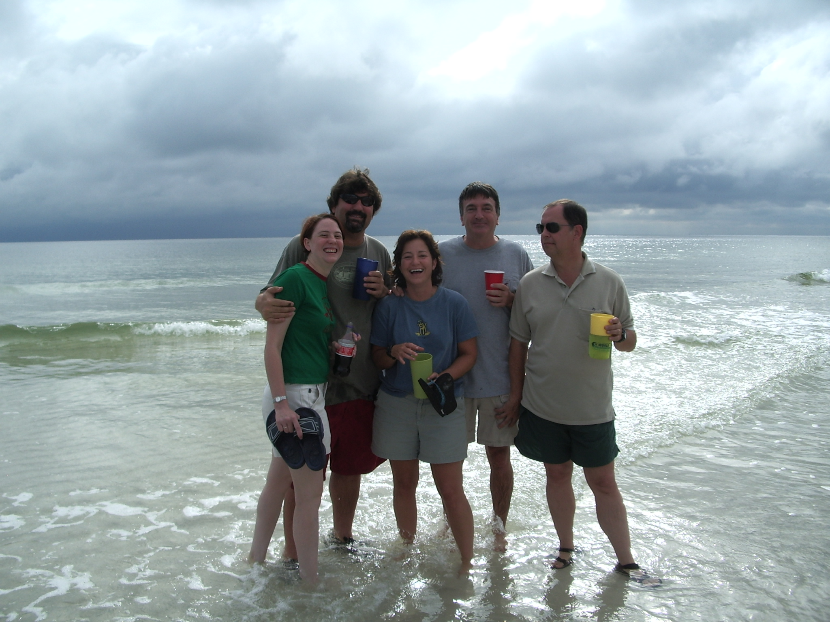
In September, we went to Tegernsee, Germany with friends for a few days of hiking and relaxing. Then it was off to the Delta Golf Tournament in Palm Springs, California for me while Tony went to Germany to meet Carina’s family.

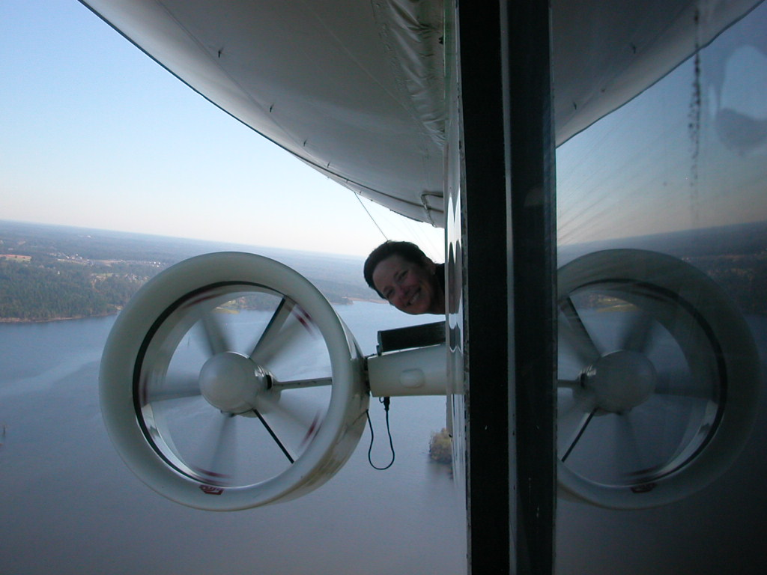
In early October we judged the Big Pig Jig BBQ Contest in Vienna, Georgia and then enjoyed a great weekend in Destin, Florida attending the wedding of two of our good friends. Carina was supposed to go home in October, but she likes it so much here that she got her internship extended until December!
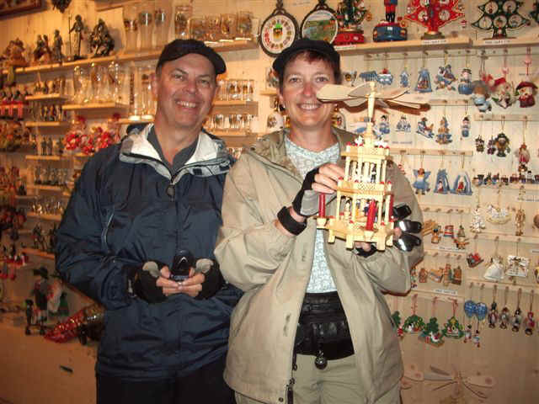
I got to ride on the Fuji blimp!
Tony and I went to Cochem, Germany with friends and bicycled along the Mosel at the end of the month. Mother was admitted to Emory Hospital for tests, and was there for three weeks. She was moved to the Bell Minor Home in Gainesville in November again for rehab.
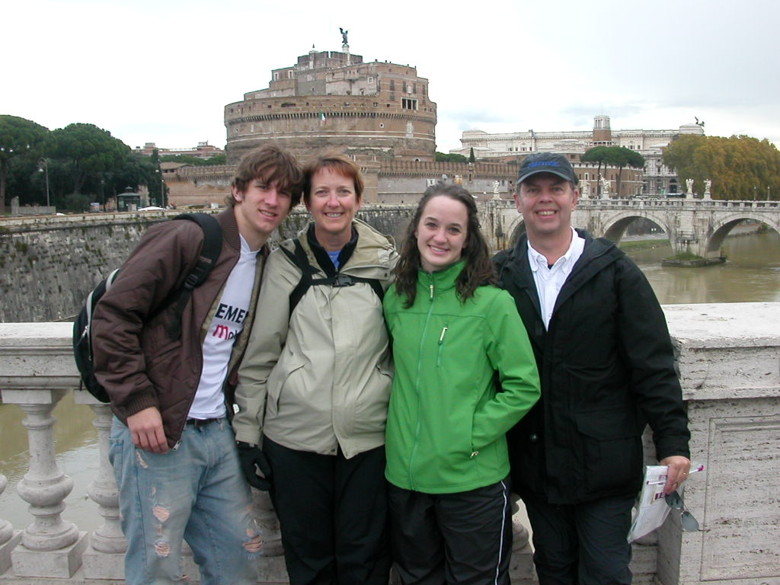
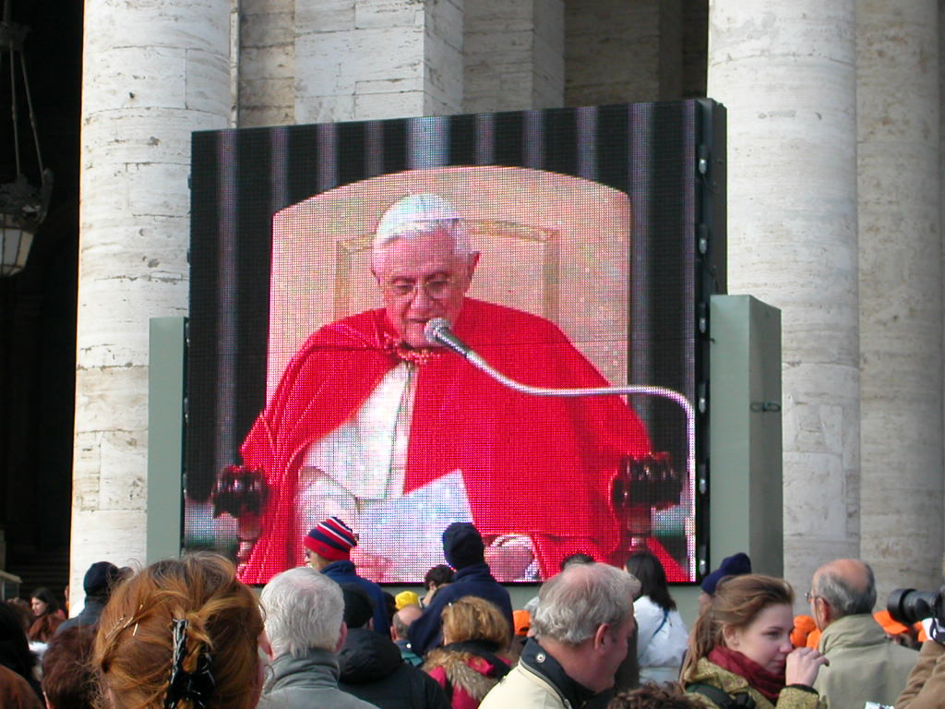
We took an overnight gambling trip to St. Louis for our friend JeRie’s 50th birthday. She got sick at the last minute and couldn’t go, but we celebrated for her.

We took my sister’s youngest two, Jared and Lauren, on a Thanksgiving trip to Rome, Italy. We even got to see the Pope!

We have had some really fun trips again this year despite all of the turmoil with my family. We are praying for a better year next year. We hope Delta can survive the difficult times and that the hurricane victims can rebuild their lives.

We appreciate the support of friends and family during this year and hope everyone has a happy holiday season! Visit our website www.bjandtony.com to read more about our travels and email us at bjandtony@bjandtony.com with your news!

